ASSESSMENT TOOL 3 – DATASET INTEGRATION TASK
Q1. Customer Dataset Integration
Aim
To clean and integrate customer data from Online, Retail, and Support systems by handling missing values, invalid values, duplicates, formatting inconsistencies, RegEx validation, fuzzy matching, and standardization, and to generate a final master dataset in CSV and JSON formats.
Input Datasets
- online_customers.csv
- retail_customers.csv
- support_customers.csv
Expected Columns
Dataset | Columns
Online | Customer_ID, Name, Phone, Email, Date
Retail | Customer_ID, Customer_Name, Phone_Number, Email_ID, Registration_Date
Support | Customer_ID, Name, Contact, Email, Date
Python Code
import pandas as pd
df = df.drop_duplicates(
subset=["Email"],
keep="first"
)

# Remove rows where email is missing from duplicate comparison
df = df.reset_index(drop=True)

# -----------------------------------
# 10. FUZZY MATCHING
# -----------------------------------

def similarity(a, b):
return SequenceMatcher(
None,
str(a).lower(),
str(b).lower()
).ratio()

print("\nFUZZY MATCHING RESULTS")

for i in range(len(df)):
for j in range(i + 1, len(df)):
score = similarity(
df.loc[i, "Name"],
df.loc[j, "Name"]
)

if score >= 0.85:
print(
df.loc[i, "Name"],
"<->",
df.loc[j, "Name"],
"Similarity:",
round(score, 2)
)

# -----------------------------------
# 11. NORMALIZE CUSTOMER NAME
# -----------------------------------

df["Name"] = (
df["Name"]
.str.replace(r"\s+", " ", regex=True)
.str.strip()
)

# -----------------------------------
# 12. EXPORT MASTER DATASET
# -----------------------------------

df.to_csv(
"customer_master_cleaned.csv",
index=False
)

df.to_json(
"customer_master_cleaned.json",
orient="records",
indent=4
)

print("\nCustomer master dataset created successfully.")
print(df)
Output
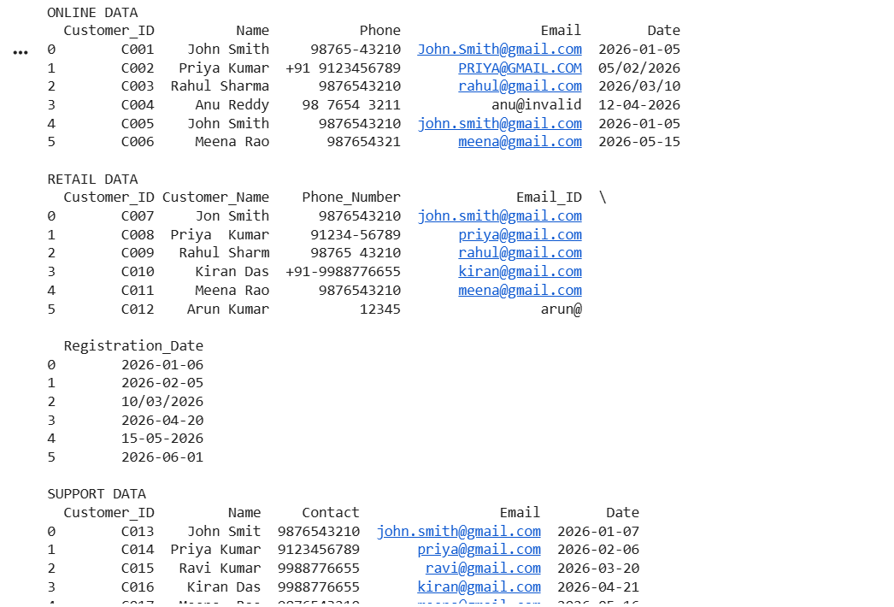
ONLINE DATA
...

RETAIL DATA
...

SUPPORT DATA
...

FUZZY MATCHING RESULTS

John Smith <-> Jon Smith Similarity: 0.95

Customer master dataset created successfully.
Generated Files
customer_master_cleaned.csv
customer_master_cleaned.json
Result
The three customer datasets were successfully integrated. Missing values, invalid emails, phone-number formatting, duplicate records, date inconsistencies, and similar names were handled using Pandas, RegEx, and fuzzy matching.

Q2. Employee Dataset Integration
Aim
To integrate HR, Payroll, and Attendance employee datasets by cleaning names, validating emails using RegEx, detecting duplicates, applying fuzzy matching, handling missing departments, detecting salary outliers, and generating a cleaned master employee dataset.
Input Files
hr.csv
payroll.csv
attendance.csv
Python Code
import pandas as pd

# -----------------------------------
# 8. SALARY OUTLIER DETECTION
# -----------------------------------

Q1 = df["Salary"].quantile(0.25)
Q3 = df["Salary"].quantile(0.75)

IQR = Q3 - Q1

lower = Q1 - 1.5 * IQR
upper = Q3 + 1.5 * IQR

df["Salary_Outlier"] = (
(df["Salary"] < lower) |
(df["Salary"] > upper)
)

print("\nSALARY OUTLIERS")
print(
df[df["Salary_Outlier"] == True]
)

# -----------------------------------
# 9. REMOVE DUPLICATES
# -----------------------------------

df = df.drop_duplicates(
subset=["EmployeeID"]
)

# -----------------------------------
# 10. FUZZY MATCHING
# -----------------------------------

def similarity(a, b):
return SequenceMatcher(
None,
str(a).lower(),
str(b).lower()
).ratio()

print("\nFUZZY MATCHING")

for i in range(len(df)):
for j in range(i + 1, len(df)):

score = similarity(
df.iloc[i]["Name"],
df.iloc[j]["Name"]
)

if score >= 0.85:
print(
df.iloc[i]["Name"],
"<->",
df.iloc[j]["Name"],
round(score, 2)
)

# -----------------------------------
# 11. EXPORT
# -----------------------------------

df.to_csv(
"employee_master_cleaned.csv",
index=False
)

df.to_json(
"employee_master_cleaned.json",
orient="records",
indent=4
)

print("\nEmployee master dataset created successfully.")
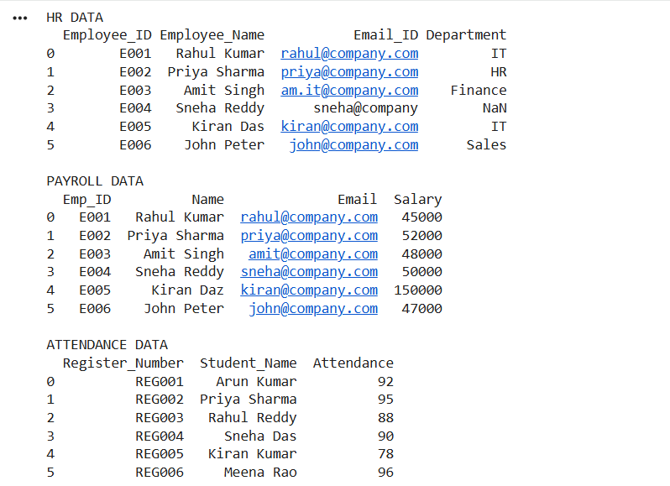
Result
HR, Payroll, and Attendance datasets were successfully integrated after handling duplicates, missing departments, invalid emails, inconsistent names, salary outliers, and formatting issues.

Q3. Product Dataset Integration
Aim
To clean and integrate Supplier, Warehouse, and Online Store product datasets using RegEx validation, fuzzy matching, duplicate detection, category standardization, price outlier detection, and numerical normalization.
Input Files
supplier.csv
warehouse.csv
online_store.csv
Python Code
import pandas as pd
Q1 = df["Price"].quantile(0.25)
Q3 = df["Price"].quantile(0.75)

IQR = Q3 - Q1

lower = Q1 - 1.5 * IQR
upper = Q3 + 1.5 * IQR

df["Price_Outlier"] = (
(df["Price"] < lower) |
(df["Price"] > upper)
)

print("PRICE OUTLIERS")
print(df[df["Price_Outlier"]])

# -----------------------------------
# 9. NORMALIZATION
# -----------------------------------

minimum = df["Price"].min()
maximum = df["Price"].max()

df["Price_Normalized"] = (
(df["Price"] - minimum) /
(maximum - minimum)
)

# -----------------------------------
# 10. REMOVE DUPLICATES
# -----------------------------------

df = df.drop_duplicates(
subset=["ProductCode"]
)

# -----------------------------------
# 11. FUZZY MATCHING
# -----------------------------------

def similarity(a, b):
return SequenceMatcher(
None,
str(a).lower(),
str(b).lower()
).ratio()

for i in range(len(df)):
for j in range(i + 1, len(df)):

score = similarity(
df.iloc[i]["ProductName"],
df.iloc[j]["ProductName"]
)

if score >= 0.85:
print(
"Similar:",
df.iloc[i]["ProductName"],
"<->",
df.iloc[j]["ProductName"]
)

# -----------------------------------
# 12. EXPORT
# -----------------------------------

df.to_csv(
"product_master_cleaned.csv",
index=False
)

df.to_json(
"product_master_cleaned.json",
orient="records",
indent=4
)

print("Product master dataset created successfully.")
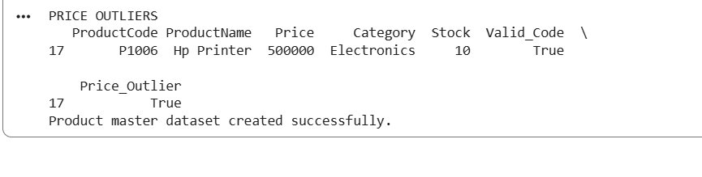
Result
The product datasets were successfully cleaned and integrated. Product codes were validated using RegEx, similar product names were identified using fuzzy matching, categories were standardized, duplicates were removed, prices were checked for outliers, and numerical values were normalized.

Q4. Student Dataset Integration
Aim
To integrate Admission, Examination, and Attendance datasets by handling inconsistent names, register numbers, dates, emails, duplicates, missing values, and formatting differences.
Input Files
admission.csv
examination.csv
attendance.csv
Python Code
import pandas as pd

df.loc[
df["Email_Valid"] == False,
"Email"
] = pd.NA

# -----------------------------------
# 7. DATE STANDARDIZATION
# -----------------------------------

df["Date"] = pd.to_datetime(
df["Date"],
errors="coerce"
)

df["Date"] = df["Date"].dt.strftime(
"%Y-%m-%d"
)

# -----------------------------------
# 8. MISSING VALUES
# -----------------------------------

df = df.fillna({
"Marks": 0,
"Attendance": 0
})

# -----------------------------------
# 9. REMOVE DUPLICATES
# -----------------------------------

df = df.drop_duplicates(
subset=["RegisterNo"]
)

# -----------------------------------
# 10. FUZZY MATCHING
# -----------------------------------

def similarity(a, b):
return SequenceMatcher(
None,
str(a).lower(),
str(b).lower()
).ratio()

print("FUZZY MATCHING RESULTS")

for i in range(len(df)):
for j in range(i + 1, len(df)):

score = similarity(
df.iloc[i]["Name"],
df.iloc[j]["Name"]
)

if score >= 0.85:
print(
df.iloc[i]["Name"],
"<->",
df.iloc[j]["Name"],
round(score, 2)
)

# -----------------------------------
# 11. EXPORT MASTER DATASET
# -----------------------------------

df.to_csv(
"student_master_cleaned.csv",
index=False
)

df.to_json(
"student_master_cleaned.json",
orient="records",
indent=4
)

print("Student master dataset created successfully.")
print(df)
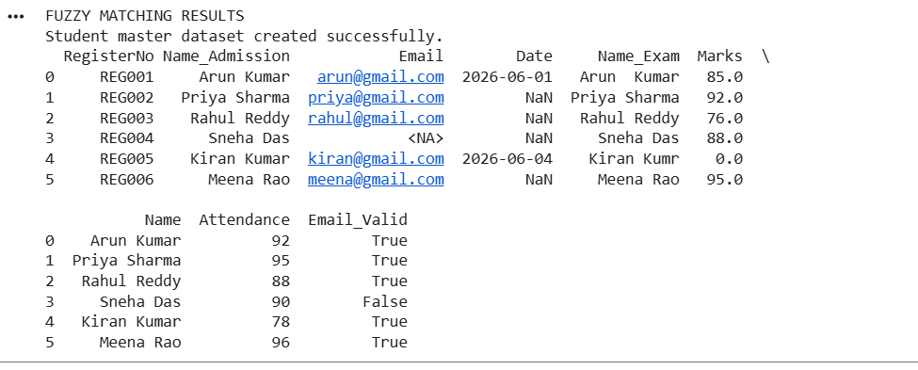
Result
Admission, Examination, and Attendance data were successfully integrated after standardizing register numbers, validating emails, standardizing dates, handling missing values, detecting duplicates, and applying fuzzy matching to identify similar student names.

Q5. Healthcare Patient Dataset Integration
Aim
To clean and integrate Registration, Laboratory, and Billing patient datasets by identifying invalid and missing values, validating phone numbers and emails using RegEx, detecting duplicates, applying fuzzy matching, standardizing dates and categories, detecting numerical outliers, and generating a final patient master dataset.
Input Files
registration.csv
laboratory.csv
billing.csv
Python Code
import pandas as pd
IQR = Q3 - Q1

lower = Q1 - 1.5 * IQR
upper = Q3 + 1.5 * IQR

df["Bill_Outlier"] = (
(df["BillAmount"] < lower) |
(df["BillAmount"] > upper)
)

print("BILLING OUTLIERS")

print(
df[df["Bill_Outlier"] == True]
)

# -----------------------------------
# 11. DUPLICATE DETECTION
# -----------------------------------

duplicates = df[
df.duplicated(
subset=["PatientID"],
keep=False
)
]

print("\nDUPLICATE PATIENTS")
print(duplicates)

df = df.drop_duplicates(
subset=["PatientID"]
)

# -----------------------------------
# 12. FUZZY MATCHING
# -----------------------------------

def similarity(a, b):
return SequenceMatcher(
None,
str(a).lower(),
str(b).lower()
).ratio()

print("\nFUZZY MATCHING RESULTS")

for i in range(len(df)):
for j in range(i + 1, len(df)):

score = similarity(
df.iloc[i]["Name"],
df.iloc[j]["Name"]
)

if score >= 0.85:
print(
df.iloc[i]["Name"],
"<->",
df.iloc[j]["Name"],
"Similarity:",
round(score, 2)
)

# -----------------------------------
# 13. EXPORT FINAL DATASET
# -----------------------------------

df.to_csv(
"patient_master_cleaned.csv",
index=False
)

df.to_json(
"patient_master_cleaned.json",
orient="records",
indent=4
)

print("\nPatient master dataset created successfully.")
print(df)
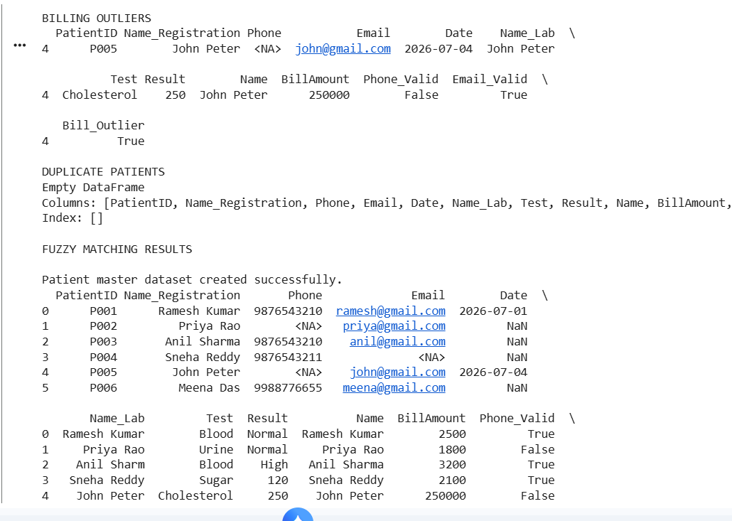
Result
The Registration, Laboratory, and Billing datasets were successfully integrated. Invalid phone numbers and emails were detected using RegEx, dates and categories were standardized, missing values were handled, duplicate patients were identified, fuzzy matching was applied to names, billing outliers were detected, and the final master dataset was exported to CSV and JSON.

Techniques Demonstrated in the Five Questions
Technique | Q1 Customer | Q2 Employee | Q3 Product | Q4 Student | Q5 Patient
Pandas | ✓ | ✓ | ✓ | ✓ | ✓
Dataset Integration | ✓ | ✓ | ✓ | ✓ | ✓
Missing Values | ✓ | ✓ | ✓ | ✓ | ✓
Duplicate Detection | ✓ | ✓ | ✓ | ✓ | ✓
RegEx Validation | ✓ | ✓ | ✓ | ✓ | ✓
Fuzzy Matching | ✓ | ✓ | ✓ | ✓ | ✓
Standardization | ✓ | ✓ | ✓ | ✓ | ✓
Normalization | — | ✓ | ✓ | ✓ | —
Outlier Detection | — | ✓ | ✓ | — | ✓
CSV Export | ✓ | ✓ | ✓ | ✓ | ✓
JSON Export | ✓ | ✓ | ✓ | ✓ | ✓
Reusable Python Logic | ✓ | ✓ | ✓ | ✓ | ✓
Final Conclusion
The five dataset integration problems were solved using Python and Pandas. The datasets were inspected, cleaned, standardized, validated, integrated, and exported. Missing values and duplicates were handled, RegEx was used for field validation, SequenceMatcher was used for fuzzy matching, and IQR-based outlier detection was applied where numerical outliers were relevant. The resulting master datasets were saved in both CSV and JSON formats, satisfying the requirements of CO3 – Dataset Integration Task.

